COVID-19 CONTACT TRACING MODEL

Submitted by  
ShunqiZheng

Jason Ferbabdez

Junior and alumni student

Name of Student’s Major

Gildart Haase School of Computer Sciences and Engineering

A **project report** paper submitted in partial fulfillment of the requirements for the course - **CSCI 3331 / 7781 Advanced Database Systems**.

Under the supervision

of

Dr. Avimanyou Vatsa

Assistant Professor, Department of Computer Science



(Fall 2020)

Problem Statement

COVID-19, declared as a Pandemic in March 2020 took the whole world into an emergency state. The efforts of some countries to fight this lethal virus have had several results. Analysis has been demonstrated that one effective method to face the virus is having control of People infected and their relationship with others.

This process was named: Contact Tracing model. So we figure out making a system combining with database system as a backend as respect to the app to tracing the contacts who carried the COVID-19 virus among the crowd to reduce the contact infecting to others.

Solution Statement

So far, Contact tracing procedures have been putting under pressure the memory of people COVID-19 positive, and their relatives. We think the best opportunity to fight the virus is given people an automatic tool that could be used by everybody. An Application that could work as a radar system and that application could build automatically a Contact List of people. Hence, If a person could result in Covid-19 Positive his contact List could be acquired easily.

This presentation gives confidential details of the solution and a simulation System built to address the objectives of the Advanced Database Course.

Technical Details

1. The Database was built in Oracle 19c where we found all the resources to finish this project.

2. Oracle Cloud Infrastructure

3. Oracle Database Modeler

4. Oracle APEX

The main roles of this system:

1. Users: Owner of the list, person who has the application installed and running.

2. Contacts: People who get close of the user at public spaces or any place.

3. The system: It will track all the people who will spend some time close to the user, mainly Two possible states a contact could have in the system. In radar or Out of radar. For a contact Out of radar, the system could identify how much time a Contact spent close to the User. In the database, Both Actors have the attribute Covid-19 Positive.

Codes:

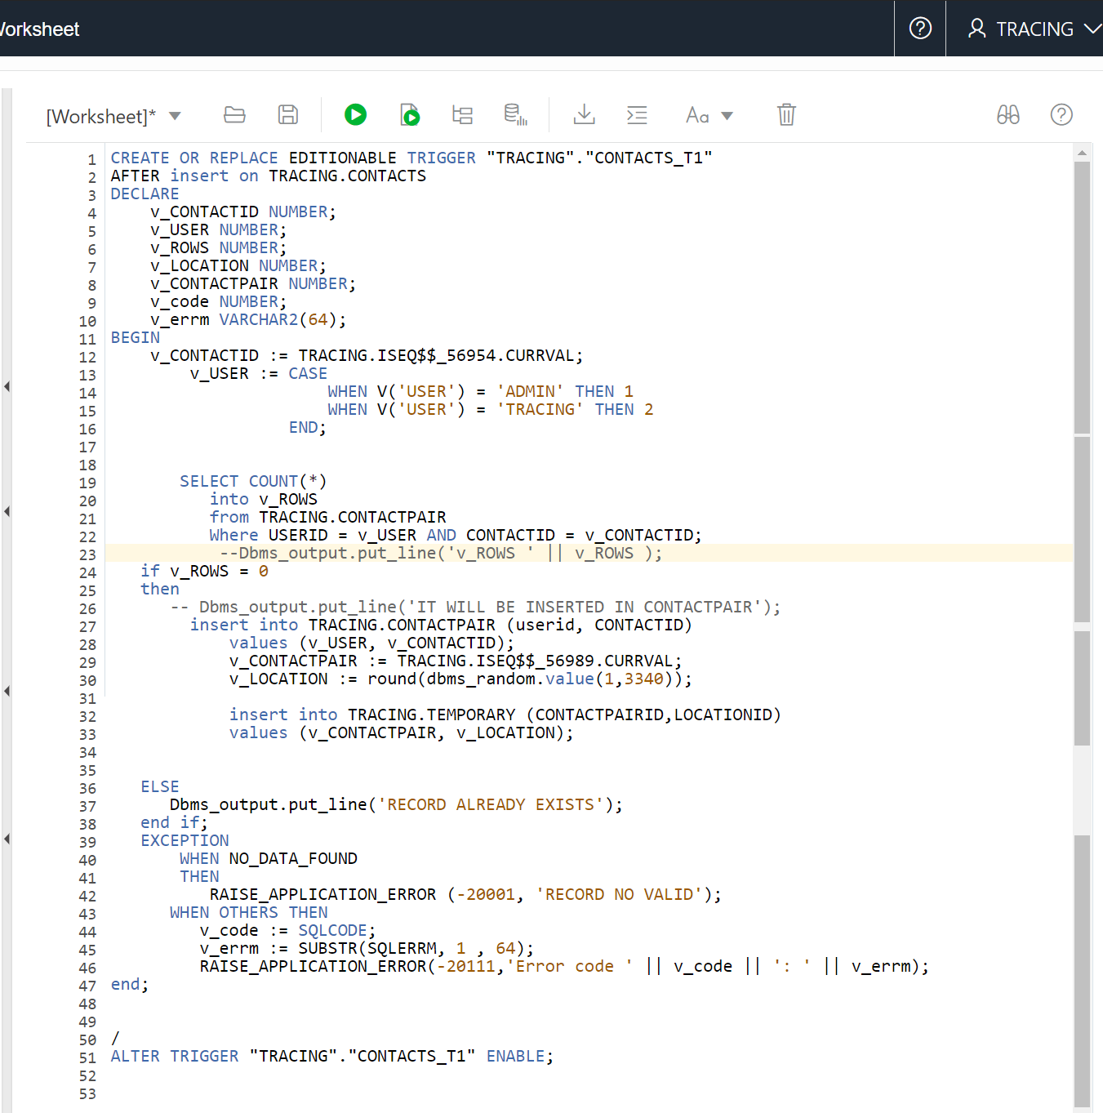

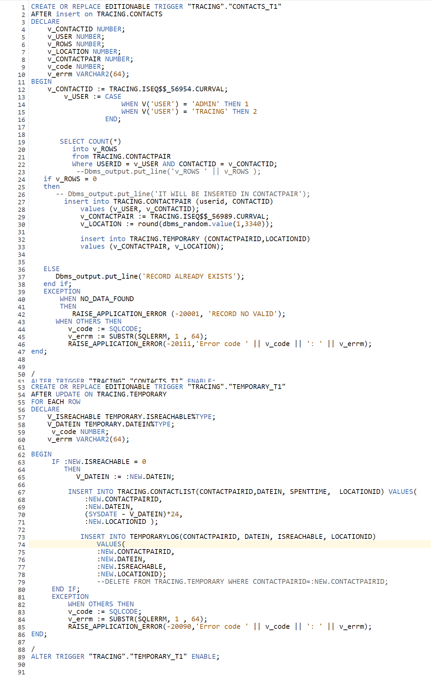

Appendix

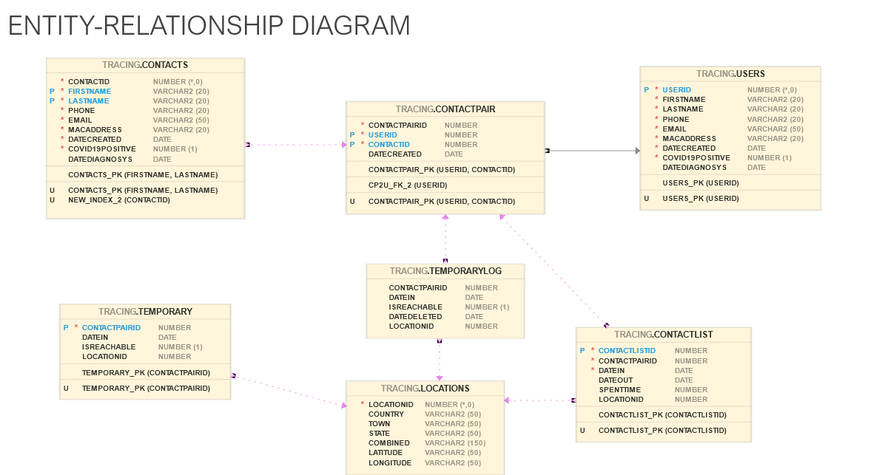

First Trigger (Contact_T1):

* This Trigger inserts a new Contact in the contacts table, Insert a new relationship User-Contact, and finally; inserts a record in the radar System Temporary table; some validations are made by the Interface of the simulator.

The second Trigger (Temporary_T1)

* Triggered when a persons get out of the radar, It moves the record in Temporary table to ContactList table specifying for how long the Contact was close of the User. Also, this trigger insert the record in TemporaryLog, this is an Entity Built to handle the log of the record deleted from Temporary Table. After this trigger A procedure will delete the record of Temporary table.

The Oracle Cloud Page:

The Simulator (Note: User Access Administrated by the Oracle Database)

Reports Radar’s Dashboard:

Contact List report:

(This report is the solution to the issues around people Covid-19 positive. Because in an easy way sanitary authorities could haveAccess to the people that could be Covi-19 Positive too)

References

[1] Oracle, O. (2020). Oracle Cloud Infrastructure Free Tier. Retrieved October 30, 2020, from <https://docs.cloud.oracle.com/en-us/iaas/Content/FreeTier/freetier.html>

[2]Bode, M., Craven, M., Leopoldseder, M., Rutten, P., &amp; Wilson, M. (2020, August 7). Contact tracing for COVID-19: New considerations for its practical application. McKinsey &amp; Company. https://www.mckinsey.com/industries/public-and-social-sector/our-insights/contact-tracing-for-covid-19-new-considerations-for-its-practical-application.

[3]Contact Tracing Workflow in a non-US setting. <https://www.cdc.gov/coronavirus/2019-> ncov/global-covid-19/contact-tracing-workflow.html.

[4]Ferretti, L., Wymant, C., Kendall, M., Zhao, L., Nurtay, A., Abeler-Dörner, L., … Fraser, C. (2020, May 8). Quantifying SARS-CoV-2 transmission suggests epidemic control with digital contact tracing. Science. https://science.sciencemag.org/content/368/6491/eabb6936.

[5]Kelion, L. (2020, April 16). Coronavirus: NHS contact tracing app to target 80% of smartphone users. BBC News. https://www.bbc.com/news/technology-52294896.